October 9, 2026 29 Tishrei 5787

Shabbat Bereshit

Torah: Genesis 1:1 – 6:8 Hertz pg. 2
Haftorah: Isaiah 42:5 – 43:10 Hertz pg. 21

Thank you to our Congregational Dinner Sponsors
Ileen Berk & Stephen Fopeano, Martin Bluestein,
Rabbi Matt & Pat Eisenberg, Liz & Bob Fertel,
Richard & Lynda Freedman, Mark & Jill Friedman,
Erika Gold, Kent & Linda Kemmerer,
Avi & Smadar Lahav, Dominic & Emily Yen.

Thank you to our Guest Speaker: Lawrence Hill on why he stands on the street and waves an Israeli flag. He was one of our Yom Kippur speakers.
Thank you to our Oneg Sponsor
Joel Wolfe in loving memory of your wife Elaine Wolfe.

We are delighted you have joined us for Shabbat.
Come to Shabbat Services every Friday night at 7:30 p.m.;
Birthday & Anniversary blessings are on the last Friday of the month.
Livestream on YouTube; search for “Temple Israel Ner Tamid.”



Matthew Eisenberg, Rabbi Mark Friedman, President
Rachel Eisenberg, Cantorial Soloist Betsy Kasperek, Administrator
Ann Teomi, Religious Education Director

Frederick Eisenberg, Founding Rabbi (of blessed memory)

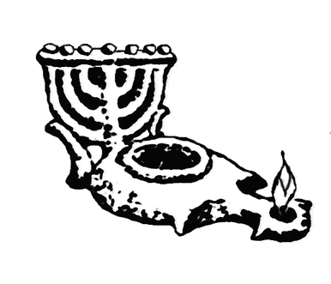

Temple Israel Ner Tamid
1732 Lander Road, Mayfield Heights, OH 44124 440-473-5120
tint@tintcleveland.org Visit our website: tintcleveland.org

Our past lights our future.


Mae’s Gift Shop is OPEN after services & Sundays during religious school
Many of the items are made in Israel.
When you patronize our gift shop,
You help support our congregation.

BORROW, DON’T BUY! – We have 2 libraries for you to enjoy.
“Check out” our adult and children’s collections, and check out
some books. Open during office, Religious School and Oneg hours

SATURDAY OCT 10 Havdalah, S’mores & Open Mic 6:56 p.m.
Open mic from 7:15 thru 8:00 p.m. Sing a song, lead a sing-a-long, play an instrument, tell some jokes. Please let the rabbi know. Oren Friedman, our Shin-Shin, will sing with the rabbi.

FRIDAY OCT 16 Shabbat 7:30 p.m.
Oneg Sponsors: Rabbi Matt & Pat on your 38th wedding anniversary. Avi & Smadar Lahav on your upcoming 30th wedding anniversary.

FRIDAY OCT 23 Shabbat 7:30 p.m.
Oneg Sponsors: Daryl & Elissa Langman in honor of your 2nd wedding anniversary.

SUNDAY, OCTOBER 25 Day Trip to Detroit 7:00 a.m.
Religious School Upper Grades and ALL TINT adults are invited to learn with us at the Zekelman Holocaust Center in W. Bloomfield.
7:00a.m. Bagels, tea, coffee at TINT.
7:30a.m. Departure from TINT.
6:30p.m. Arrival back at TINT.
We have a BIG bus to fill, so come with us.
$18 per RS student and any student prior to college graduation,
$36 per adult. We will have lunch at the Stage Deli. This trip and deli lunch will be substantially subsidized by the Lenore & Robert
November Memorial Fund, The JEC & Rabbi is looking for additional sponsors at $180.00. Please contact the office.

WED OCTOBER 28 Israel December 2027 6:30-7:45 p.m.
Come to Israel with Rabbi Matt & Pat. We plan to meet in Tel Aviv, Sunday, December 19, 2027 to begin a 12-day tour of the Holy Land. This is our FIRST informational meeting to begin to shape the itinerary.

FRI OCTOBER 30 5th Friday Jam After Services
Steven Greenman – Violinist

SUN NOVEMBER 1 DAYLIGHT SAVINGS TIME 2:00 a.m.
Turn your clocks back and don’t be too early to religious school!

THUR NOVEMBER 5 Men & Women Talking Torah 6:30-7:45 p.m.
Gen 23:1 “And the life of Sarah was a 100 and 7 and 20 years…”
Why does Sarah have a Torah portion named after her?
Want to sponsor the nosh? Call the office.
(Next class Monday December 7)

SUN NOVEMBER 8 12:00 p.m. The Torah of Tax: Tzedakah That Pays Off.
Beechmont Country Club 29600 Chagrin Blvd.
Call TINT office to RSVP.

FRIDAY NOV 13 Congregational Dinner & Shabbat 6:15 p.m.
“Thanksgiving in a sandwich from Davis Bakery and salad”.

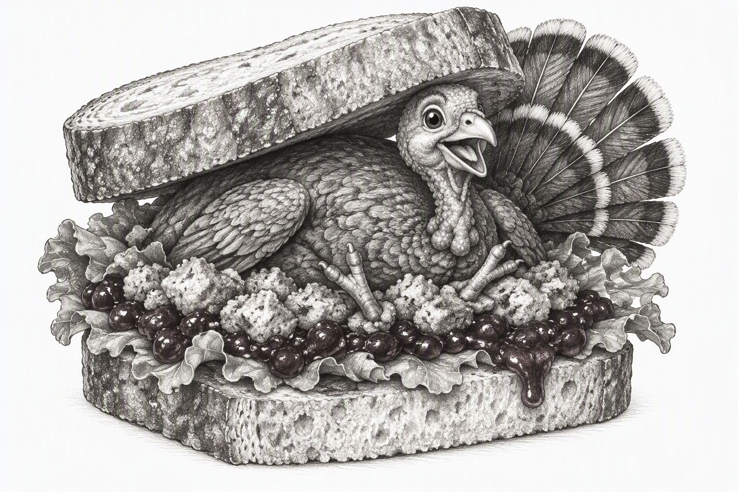

Dinner Sponsors so far: Bob & Liz Fertel, Jan Tucker in memory of your brothers David (81st BD) & Stuart (84th BD)
(Next dinner December 11)

SATURDAY NOV 14 Havdalah, Donuts & Open Mic 5:11 p.m.
Open mic from 5:30 thru 6:15 p.m. Sing a song, lead a sing-a-long, play an instrument, tell some jokes. Please let the rabbi know. Oren Friedman, our Shin-Shin, will sing with the rabbi.
(Havdalah Dec 12, 2026, 5:00 p.m. Open mic at 5:20 – 6:05p.m.)

THURSDAY NOV 19 4:00-8:00 p.m.
19th Annual Emil Spitzer Memorial Golf Outing. This is a fundraiser at Top Golf. Plan your groups and get ready for a great afternoon at the premier indoor driving range. All ages welcome! See the flyer in the Pamphlet Tower.

SHABBAT PB&J TZEDAKAH (Peanut Butter & Judaism)
We need peanut butter (smooth is easier to use than “natural”) and jam, jelly, preserves. We need QUART Sized Ziplock bags, or other zipper bag brands to make about 180 PB&J sandwiches during the Oneg Shabbat to be distributed to Cleveland’s needy. Please join us. We need more tzedakah drivers. Ask the Rabbi. Rabbi Matt rides in the PB&J van on the first and last Fridays of the month. Join him. We’re making the world a better place, one PB&J sandwich at a time.

We need:
- New or cleaned blankets or sleeping bags
- New or cleaned coats & jackets for adults & children,
plus hats, gloves, mittens and scarves
- NEW socks in unopened packages for adults & kids,
plus NEW adult & children’s underwear in packages
- Feminine hygiene products, personal toiletries especially travel-sized

Temple Office Hours:
Sunday, 9:00 a.m. to 1:00 p.m. when religious school is in session
Monday, Wednesday & Thursday: 9:00 a.m. to 5:00 p.m.
Friday, 9:00 a.m. to 1:00 p.m.

Our Past Lights
Our Future

Our Mission Statement
Temple Israel Ner Tamid is a caring, accepting, Reform Jewish congregation providing a welcoming place to gather, pray, learn and engage in acts of kindness and Tzedakah.

